Dear LBJ Friends,
President Johnson created a public policy school to produce leaders and doers. The Austin Area Chapter of the LBJ Alumni Association fully supports this idea of involvement and leadership as envisioned by the founders of the LBJ School of Public Affairs.
To encourage students to be involved in the greater LBJ community and to reward those who go above and beyond, the Austin Chapter of the LBJ Alumni Association established the Spirit of LBJ Award. We are seeking nominations for the ninth annual recipient of this honor. Please nominate returning students who you feel are deserving of such recognition. Nominations (due August 15, 2016) may be accepted on behalf of a student or from individuals themselves.
WHAT IS THE AWARD?
One scholarship of $500 and recognition of the recipient at a public event to be arranged by the Austin Area Chapter of the LBJ Alumni Association. The recipient will also have their name engraved on a plaque that hangs in the OSAP office.

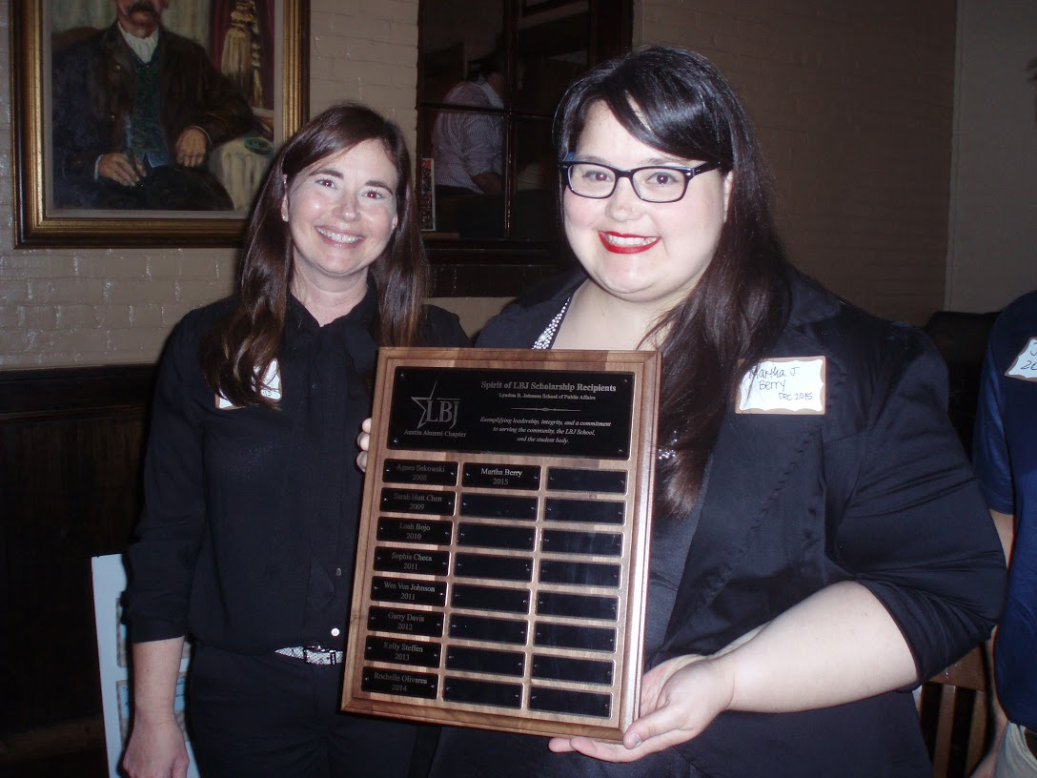
2015 Spirit of LBJ recipient – Martha Berry

WHO IS ELIGIBLE?
Any returning student at the LBJ School with less than 35 credit hours earned toward a Master’s Degree and who is in good standing with the University of Texas. Nominees/applicants will be considered to be in good standing if they have:
- A cumulative GPA of at least 3.0
- Are not on academic probation
- No bars to registration, such as financial or advising bars
- No disciplinary actions outstanding.

The following students are ineligible:
- Any student not in good standing with the University of Texas based on discussion with OSAP
- Any student with more than 35 credits earned toward a degree from the LBJ School
- Holder of the Barbara Jordan Scholarship or Holder of the Ben Barnes Fellowship*

WHAT CHARACTERISTICS SHOULD THE AWARD RECIPIENT POSSESS?
- Past, present, and future commitment to serving the larger community, LBJ School, and student body
- Leadership
- Strong sense of ethics and integrity
Nominations should provide an overall picture of the nominee's contributions to and achievements in public service with consideration given to the following:
- Community service activities
- Overall distinguished quality of work
- Examples of significant results achieved
- Innovative ideas recognized and/or implemented
WHAT IS THE APPLICATION PROCESS?
Submit a few paragraphs (maximum one page) communicating why you believe the nominee (you can also nominate yourself) is deserving of the award, along with any supporting documents to the Austin Chapter of the LBJ Alumni Association at lbjschoolaustinalumniassoc@gmail.com.The application deadline is August 15, 2016.

HOW WILL THE AWARD RECIPIENT BE CHOSEN & WHEN WILL THE AWARD BE ANNOUNCED?
The award recipient will be chosen by the Board of the Austin Chapter of the LBJ School Alumni Association, with input from a committee comprised of faculty and staff members, alumni, and a current student. The Austin Chapter of the LBJ Alumni Association will notify the winner around when fall 2016 classes begin.

FOR ADDITIONAL INFORMATION, PLEASE CONTACT Racheal Kane at rachealkane@utexas.edu or (512) 565-5420.
* Nominations of any recipients of any other high-standing LBJ School fellowship or scholarship that is publicly released by the LBJ School and the OSAP office will be evaluated and taken into consideration by the Austin Alumni Association Board, who will choose the award recipient.

